SMART SOLUTION FOR RAILWAYS

TEAM ID:PNT2022TMID35794

SPRINT-1: SIGN-UP & LOGIN:

NODE RED:

BACK-END SCREENSHOTS:
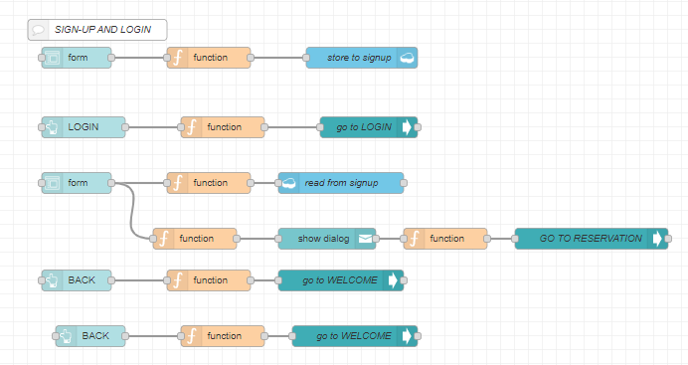

SIGN-UP SCREEN:
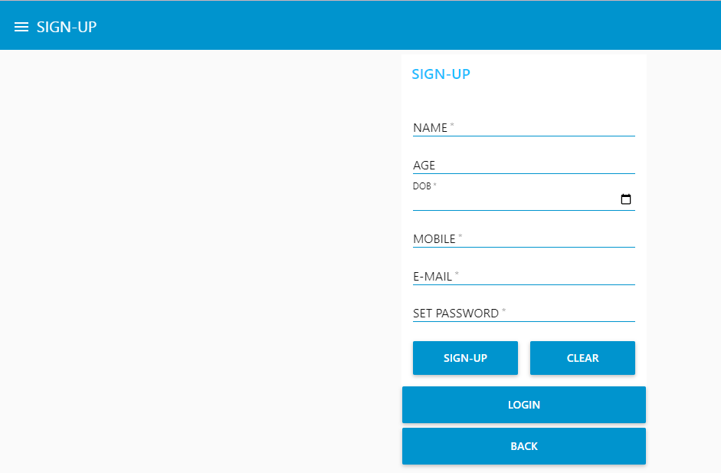

LOGIN SCREEN:
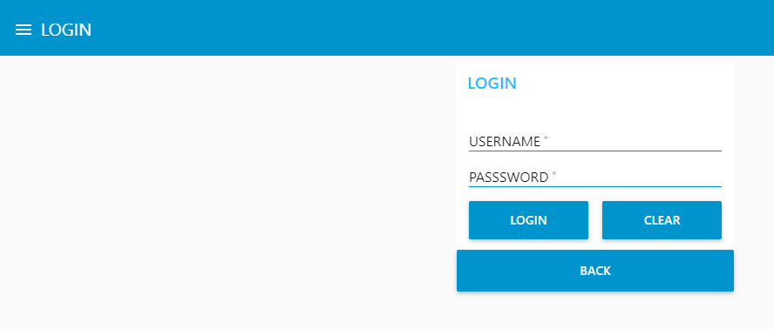

IBM CLOUDANT STORAGE:(DATABASE: signup)
